Temenos XAI Cash Flow Feature in DBX
Business Requirement Document

Client Solutions

Version: DRAFT
Date Last Published:
Author(s): Hoa Bach

Revision History
Version | Date | Authors | Revision Notes
0.1 | November 4, 2020 | Hoa Bach, Edmund Chua, Sunil Prashar | Initial draft
0.2 | November 23, 2020 | Hoa Bach | Removed all CODAT references due to scope change
0.3 | November 24, 2020 | Sunil Prashar | Updated Scope and Business Requirement sections

Review and Contributions

Version | Name | Role | Updates
0.1
The following is a list business and technical representatives who have reviewers and/or contributed to this document:

Related Document References

The following reference information is relevant to this project:

Ref ID | Document and embedded link | Short Description
REF-003 | Temenos XAI Data Provisioning Process | A Visio diagram that describes the CWB process to approve data before delivering to external entity
REF-006 | Customer Funds Flow XAI Model Solution Doc | A Temenos XAI model predicts the monthly disposable income for each customer.
REF-007 | [17th Sept] Temenos Infinity_CWB_Accounting Dashboard.pptx | Features presentation from Prema of temenos
REF-008 | SME Digital Platform Differentiators_CWB_Sept2020.pptx | Requirement presentation from Prema of temenos
REF-009 | CWB Architecture 2020-11-04 (RACI).pdf | Conceptual CWB architecture diagram

Glossary

Acronyms
Acronym | Full Text
API | API (application programming interface) - a software intermediary that allows two applications to talk to each other
DBX | Digital Banking Experience
GRC | Governance Risk & Compliance
SME | Small/Medium Enterprises: The SME risk rating segment represents traditional commercial / EFG deals, for borrower's authorized balance plus proposed exposure greater than 500K, where the company is not publically traded or part of a syndication, and deal is not 100% for facilities of Commercial Real Estate deals (including Income Producing Real Estate and/or Interim Financing Projects).
SMS | SMS (short message service) is a text messaging service component of most telephone, Internet, and mobile device systems.
TDL | Temenos Data Lake is a next generation big data platform built specifically for banking. It is fully integrated with modern banking software products such as Temenos Transact and Temenos Infinity. It delivers out-of-the box, real-time, multi-source data streaming, data integration, data preparation and data optimization to empower banks with the highest quality data to power reporting, analytics, and AI-driven digital banking applications.
XAI | Temenos Explainable Artificial Intelligence Models: these are Temenos’ patented machine learning models delivered as SaaS allowing banks to accelerate digital onboarding, conduct eligibility checks and process loan applications for SMEs and retail customers. These models predict events – such as Customer Attrition, Funds Flow, Customer Lifetime Value, Next Best Product.

Terms
Term | Definition
CODAT | Codat is a cloud-based software that provides seamless integrations of your product (lenders, banks, and insurance companies) with all the major accounting platforms used by small business customers – all through a single API. It acts as a data processor when building integrations, mapping data in a standard format independent from the accounting software that your customers use.
MuleSoft | MuleSoft provides the most widely used integration platform (Mule ESB & CloudHub) for connecting SaaS & enterprise applications in the cloud and on-premise. Connect apps, data and devices anywhere, on-premises or in the cloud.
Temenos Infinity Spotlight | Temenos Infinity Spotlight is a browser-based console that enables a holistic, full view of the customer, which integrates with core banking systems and third-party services, allowing bank staff to manage and assist account holders in their banking journeys. It collects everything the banker needs to know about their account holder in a convenient web based interface, with data matching what the account holder sees from their own mobile or online interface.
Temenos Infinity | An internet and mobile banking application that enables CWB to provide a personalized experience to its customers. It has 6 different aspects – Temenos Channels, Analytics, User Administration, Front Office solutions, Financial Crime Mitigation and Origination.
Temenos | Temenos AG is a company specialising in enterprise software for banks and financial services, with its headquarters in Geneva, Switzerland. Temenos acquired Logical Glue in July 2019.
Temenos Insight | Temenos’ Insight is a business intelligence, analytics, and reporting data warehouse that is fully integrated with T24, and provides specialist out-of-the-box products for:  - Financial Intelligence: Balance Sheet and P&L Reporting, Budgetary Reporting, Securities  - Risk Intelligence: Regulatory Capital (incl. Basel II, III), Market Analytics, Asset & Liability Management (ALM)  - Customer Intelligence: Customer & Product Profitability, Sales Analytics  - Operational Intelligence: Product Pricing Analysis,Teller Capacity Planning
Temenos Transact | Temenos T24 Transact is a real time, cloud native core banking system.
Logical Glue | A SaaS-based, self-service Explainable AI (XAI) platform, AI credit scoring models, built to address business solutions. Logical Glue was a software company acquired by Temenos in July 2019.

Table of Contents
Revision History 2
Review and Contributions 2
Related Document References 2
Glossary 3
Acronyms 3
Terms 3
1 Document Purpose 7
1.1 Document Scope 7
1.1.1 In Scope 7
1.1.2 Out of Scope 7
1.2 Document Intended Audience 7
2 Business Overview 8
2.1 Business Problem Statement 8
2.2 Key Business Differentiators and Objectives 8
3 Stakeholders 9
3.1 Sponsor Information 9
3.2 Stakeholder Information 9
4 Requirements 11
4.1 Business Requirements 11
4.2 Regulatory Requirements 13
4.3 Solution Requirements 13
4.3.1 Functional Requirements 13
4.3.2 Non-Functional Requirements 15
4.3.3 Service Level Requirements (SLRs) 16
4.4 Data Requirements 16
4.5 Transition Requirements 16
5 Assumptions, Dependencies and Constraints 18
5.1 Assumptions 18
5.2 Dependencies 18
5.3 Constraints 19
6 Business Benefits 20
7 Business Risks 20
8 Signature 21
Appendix A – Predictive Cash Flow and Accounting Dashboards 22
Appendix B – Cash Flow Predictive Features 26
Appendix C – Consent Model 27

Document Purpose
This Business Requirements Document (BRD) is an agreement between Client Solutions (CWB) and Temenos Team that defines the requirements for developing the XAI Cash Flow Feature in DBX utilizing the Temenos technology stack.

Document Scope
The scope of this document is to define requirements for building the XAI Cash Flow Feature in DBX that helps our small business clients with their cash flow so they can run their business more efficiently and feel empowered to make decisions, have more time, and focus on the growth of their business. We want to use data and XAI to drive smart insights and create an intuitive user experience for our clients.
This document contains requirements at the level of detail understood by the stakeholders at this point in time. Content will be updated to reflect new information as it becomes available. Therefore, any printed copy of this document is considered invalid.

1.1.1 In Scope
The solution will be delivered in two releases as scoped below:
Release 1
- Temenos approved technical architecture (include TDE/TDL and more)
- Temenos Cash Flow Predictive XAI Model
- Infinity Digital Banking (Mobile, CWB OLB) enhancement
- Client Cashflow Visuals (out-of-the-box and custom built charts and graphs)

Release 1A
- CODAT Integration (including Mulesoft)
- CODAT Onboarding through DBX, SME Platform
- Client Consent and Entitlement Manegement (for CODAT onboarding)
- Client Cashflow and Accounting Visuals (integrated)

1.1.2 Out of Scope
The following items are deemed not in scope for this solution:
- Purchase of data sources
- Cash flow simulation
- Advanced analysis of cash flow and accounting (none out of the box XAI insights – refer to [17th Sept] Temenos Infinity_CWB_Accounting Dashboard.pptx)
- Integration with other banks

Document Intended Audience
This document contains confidential information intended for the specific audience listed below. The information in this document may also be legally privileged. If you are not listed below, please contact the document author noted on the front page.
- Executive Sponsor
- Applicable Business Areas (Client Solutions, Digital, Relationship Manager)
- Project Management Office
- Organization Chanage Management
- Data Governance
- Legal Services
- Information Security Office
- Infrastructure and Operations
- Business Analysis
- Enterprise Architecture
- Quality Assurance
- ClearSight Solutions (vendor)
- Temenos (vendor)

Business Overview
The acquisition of the Temenos XAI (Explainable Artificial Intelligence) technology platform in early 2020 makes CWB the first in Canada to leverage the Temenos Explainable AI capabilities to offer a differentiated digital banking experience for small-to-medium-sized business owners.
The goal of levering the Temenos Cash Flow Predictive XAI model is to help our small business clients with their cash flow so they can run their business more efficiently and feel empowered to make decisions, have more time, and focus on the growth of their business. We want to use data and XAI to drive smart insights and create an intuitive user experience for our clients.

Business Problem Statement
Based on our research, our small to medium sized businesses feels overwhelmed with administration, unsure and intimidated about how to run their day to day operations. They want to understand how to run their business more efficiently and when to grow their business. We can solve this problem by creating a feature focused on giving insight and managing their cash flow more effectively. We will leverage the Temenos Cash Flow Predictive XAI model, use data to drive the model, and provide insights to our clients.
This Feature will solve the following problems:
- Lack of understanding of their cash flow; wants to manage their money more effectively
- Manual day-to-day operational inefficiencies
- Lack of real-time data and insights

- Poor client experience
- Lack of proactive client relationships; would like to move from service to partner relationship

Key Business Differentiators and Objectives
Our objective is to help SME’s manage their day to day activities and focus what they value most.

Our key differentiators for SME’s:
- Integrated view of their business from one dashboard or area
- Intuitive user interface for all core banking and payment services
- Detailed view of cash flow based on banking data
- Explainable Artificial Intelligence (XAI) will generate actionable insights for the SME. The insight will provide the SME with information on next action. E.g. SME is experience a Cash Flow problem, here are the reasons why and what actions can be taken.
- A trusted partner with CWB, augmenting the digital experience with a human partnership

The business objectives:
- Remain competitive with our competitors by integrating XAI technology in DBX
- Be first to market using XAI technology to help solve one of SME’s biggest problems
- Increase our client base through digital offerings
- Provide excitement to our investors
- Use data and insights to help educate our clients

The release 1 is projected to be delivered by April 2021, with the joint development effort from CWB team and Temenos.

Stakeholders

Sponsor Information
Department: | Client Solutions, CWB
Requestor: | Edmund Chua, AVP, Digital Strategy & Innovation
Business Sponsor: | Christina Mullin, VP, Digital & Alternative Channels

Stakeholder Information
Vendors:
Lead Name | Vendor | Role | Stake\ Interest | Level of Engagement  (H \ M \ L)
Brandon Spooner | Temenos | Account Manager | Temenos relationship with CWB | High
Liam Laurent | Temenos | Project Governance | Temenos Project Consulting Services | High
Rayce Rossum | Temenos | Principal Data Scientist | Temenos Analytics Develpment | High
Prema Varadhan | Temenos | Chief Architect and Head of AI | Temenos Solutions Oversight | High
Lael Locher | Temenos | Analytics Product Manager | Temenos Products | High
Colin Hardie | Temenos | Chief Data Architect | Temenos Data Architecture | High
Hani Hagras | Temenos | Chief Data Scienctist | Temenos XAI Models | High
Mark Terry | ClearSight | CWB / Temenos Partner | Implement/Supports Temenos Infrastructure | High
TBD | Temenos | Business Analyst | Temenos Solution Requirements | High

CWB stakeholders:
Lead Name | Role | Stake\ Interest | Level of Engagement  (H \ M \ L)
Edmund Chua | AVP, Digital Strategy & Innovation | Subject Matter Expert, SME DBX | High
Christina Mullin | VP, Digital & Alternative Channels | Business Sponsor | High
Dilshad Bhatti | Program Manager | DBX Project Deliverables | High
Nadine Filice | Sr. Project Manager | Infrastructure Deliverables | High
Mike Maxfield | Program Manager | Infrastructure Deliverables | High
Dino Noce | Program Manager | DBX Project Deliverables | High
Reinhardt Tonn | Solutions Architect | Solutions Architect | High
Jose Barril | Solutions Architect | Solutions Architect | High
Joanne Pearson | Information Security | Infrastructure Security | Medium
Colette Leung | DG Analyst | Data Governance | High
Tim Sande | DG Lead | Data Governance | High
Kevin Vadnais | Governance Risk & Compliance | Data Security & Risk | Medium
Hoa Bach | Sr. Business Analyst | Business Rquirements | High
Sunil Prashar | Sr. Business Analyst | Business Rquirements | High
Winnie Ng | Analytics Architect | Infrastructure Consultant | Medium
TBD | Marketing & Communication

Requirements
Requirements will be prioritized using the MoSCoW technique as per the industry standard Business Analysis Body of Knowledge (BABOK®). The categories and descriptions are as follows:
- M - MUST: an item that must be included in the final solution for the project to be successful
- S - SHOULD: a high priority item that should be included in the solution when possible. This is often a critical requirement but one can be satisfied in other ways if strictly necessary
- C - COULD: an item being considered desirable but not necessary. This will be included if time and resources permit
- W - WON'T: an item that stakeholders have agreed will not be implemented in a given release, but may be considered for the future releases.

Figure 1 - A depiction of the relationship between the types of requirements. | - Business Requirements describe what the business wants to achieve.  - Regulatory Requirements identify which regulation, policy and standards with which the solution complies.  - Stakeholder Requirements define the needs of a particular group of stakeholders and what they require of a particular solution.  - Solution Requirements  - Functional Requirements describe what the solution should do to fulfill the business needs.  - Non-Functional Requirements describe the qualities of the solution in terms of speed, security, availability, userability, portability, etc.  - Service Level Requirements a sub-category of non-functional requirements that describe the constraints of the solution as defined in a Service Level Agreement.  - Data Requirements define the data elements and their relationships reguired for the solution  - Transition Requirements define characteristics that a solution must have in order to transition from the current state to the future future.

Business Requirements

ID | Business Requirements Description | Release | MoSCoW
BR01 | Clients must be able to see a visual of their cash flow within digital banking  - Predictive Cash Flow ( Temenos Cash Flow Predictive XAI model)  - Historic Cash Flow  - Payable & Receivables – Summary  - Payable & Receivables – Overdue  - Payable & Receivables – Future Due  - Receivables – By Customer  Other visualization, depending on Customer data availabilities:  - Payable & Receivables – By Supplier / Customer  - Customers and Suppliers (tables)  - Other visuals deem valuable during the development cycle  Refer to Appendix A – Predictive Cash Flow and Accounting Dashboards | 1 | Must
 |  | 1A
BR02 | Create an intuitive UI to deliver better client experience (key differentiating factor) | 1 | Must
BR03 | Use core CWB banking data and other sources (e.g. Moody’s) to generate a complete view of their cash flow (key differentiating factor) |  | Must
BR04 | XAI model must continually learn and become more accurate over time. |  | Must
 |  | 1A
BR05 | Provide feature usage statistics – ability to view and measure client’s engagement with this feature through Temenos analytics. Example includes client’s who viewed historical data, view insights, etc.  Note: use what Temenos Analysitcs can provide out of the box as a starting point. | 1 | Must
BR06 | Leverage our Go to Market strategy and engage early adopters to be beta users to learn and gain feedback of the feature |  | Must
BR07 | Apply CWB style guide for graphs, charts and other UI components |  | Must
BR08 | XAI Insights generated must be in friendly, understandable and clear language. |  | Must
 |  | 1A
BR10 | Ensure change management plan is in place |  | Must

Regulatory Requirements
The following items have been reviewed and documented in alignment with CWB’s Regulatory Compliance Standards.
ID | Requirements Description | MoSCoW
RR01 | The solution must align with the Data Governance and GRC requirement (data privacy and security), and be compliance with the guidelines and practices in keeping with CWB Information Services standards. | Must
RR02 | The solution must align with the data retention policy of CWB (especially for data on the Cloud). | Must
RR03 | The solution must satisfy the auditing requirement. | Must

Solution Requirements
The underlying technical architecture and platform must be in place to support the functional / non-functional requirements and service level requirements described below.

Functional Requirements
To be fleshed out with Temenos
ID | Business Requirements Description |  | Release | MoSCoW
 |  | Historic and Predictive Modelling
FR01 | Based on the cash flow XAI model, analyze client data from CWB transaction history, and data from other sources, to calculate cash flow trends (historical and predictive forecasting) and display via a new tile on the desktop
FR02 | Dashboard display should be graphical, allow adjustments by the user to display by different data ranges and show summary totals for Money In and Money Out
FR03 | Display Cash Runway calculation for users on dashboard to help identify health of the business (future phase?)
FR04 | Enable drilldown to allow clients to determine what data (features) was used to calculate and forecast. Also filter options will be available for data findings to view by payables and receivables, spending patterns etc.
FR05 | Access will be entitlement driven at the client and user level
FR06 | Enable user activity tracking and analysis for all cash flow features and provide automated data extracts to enable billing
 |  | Actionable and Predictive Insights for Clients
FR07 | Based on cash flow and other XAI model analysis, generate insights for clients that will be pushed via multiple channels (Digital Banking, SMS, Push Notifications etc.) (future phase)
FR08 | Include insights based on patterns and best practices for financial management. This may include payable and receivable processing, supplier management etc.
FR09 | Allow users drill down to determine how insights were generated (is this duplication of FR04?)
FR10 | Insights will be prominently displayed on the dashboard and clearly show new Insights and provided access view of all Insights (read and unread) and enable users to save, delete and share with other users who are entitled to view/receive.
FR11 | Users can select preferred channels for Insight delivery via profile preferences. Insight content will be generated based on the channel (secure vs. non secure)
FR12 | Access to receiving and drilling down into insights will be managed via entitlements at the client and user level.
FR13 | Enable user activity tracking and analysis for Insights and provide automated data extracts to facilitate billing (as needed)
 |  | Accounting Integration – 2 Way Data Sharing
FR14 | Partner with aggregator (CODAT) for Accounting data that offers integration to majority of market leading Accounting products in Canada (future phase)
FR15 | Capture consent for data sharing (push and pull) and store with client data (future phase)
FR016 | Entitlements to control data sharing access permissions and viewing of data results on a per client and user level.
FR17 | Enable clients to securely connect to their preferred Accounting Partner to setup ongoing data sharing into CWB (pull). Secure authorization is a one-time action.
FR18 | Enable clients to securely connect to CWB API to share (push) transaction data for one or more of their CWB accounts to their preferred Accounting Partner. Secure authorization is a one-time action that will require CWB to have a separate login page to enable data sharing (possibly via OKTA, TBC).
FR19 | Access controls to allow the user to disconnect data sharing (both push and pull). For CWB data, users must be able to enable/disable each account.
FR20

Non-Functional Requirements
ID | Business Requirements Description | MoSCoW
NF01 | Mobile application response time?? | Must
NF02 |  | Must
NF03 |  | Must
NF04 |  | Must
NF05

Service Level Requirements (SLRs)
[Service Level Requirements are a sub-category of Non-Functional Requirements. They are the constraints of the organization being served by the solution that are formally agreed and will be captured and managed in the Service Level Agreement. Please ensure this section accurately reflects client needs, because inflated expectations may lead to over-engineering, thus increased costs.]
ID | Business Requirements Description | MoSCoW
SL01 |  | Must
SL02
SL03
SL04
SL05

Data Requirements
The following data is required for this solution:
ID | Business Requirements Description | MoSCoW
DR01 | Customer Cashflow SME and Retail BRD | Must
DR02 |  | Must

Transition Requirements
[Transition Requirements describe the capabilities that the solution must have and conditions it must have in order to facilitate transition from the current state to the future state, but are not needed once the change is complete. They are differentiated from other requirements types because they are of a temporary nature. Transition requirements address things like data conversion, training, and business continuity.]
ID | Business Requirements Description | MoSCoW
TR01
TR02
TR03
TR04
TR05

Assumptions, Dependencies and Constraints
This section allows for documenting the assumptions, dependencies, and constraints that cannot be ascertained in advance. These items may feed the Business Risks section that follows.

Assumptions
The following assumptions have been made regarding this project. Each assumption is an ‘educated guess’, a likely condition, circumstance or event, presumed known and true in the absence of absolute certainty. Assumptions are made to fill knowledge gaps; they may later prove to be incorrect but could have a significant impact on the project/initiative.

ID | Assumption
AS01 | All data acquisition, movement, storage and manipulation will utilize both Temenos and CWB personel.
AS02 | All configuration, analysis, development and testing of analytic components, solutions and or capabilities will include CWB information management (particularly Enterprise Analytics team) personnel .
AS03 | Technical installation and configuration work will utilize both Temenos and CWB personnel.
AS04 | Temenos technologies and their functionalities will deliver as advertised / promised / expected.
AS05 | Temenos support will be available in a timely fashion for CWB.

Dependencies
The following list of business related dependencies have been identified:
DP01 | Temenos Architecture Infrastructure | The underlying Temenos TDE/TDL technology platform must be available to support this solution.
DP02 | Temenos Cash Flow Predictive XAI Model | The Temenos Cash Flow Predictive XAI Model and Platform must be available to use.

Constraints
[Typical constraints may include: fixed budget, limited resources, imposed interim and/or end dates, predetermined software systems and packages and other predetermined solutions. Each constraint is a limiting condition, circumstance or event, setting boundaries for the project process and expected results.]
The following constraints have been identified:

CT01 | Trade off between scope and budget may occur during the course of this development project in order to fit the solution delivery timeline.
CT02 | This solution delivery timeline may be affected by the Temenos’ development effort and response time.

Business Benefits
This solution will benefits CWB in the following areas:
- Better understanding of the customers cash flow
- Improved the day-to-day operation
- Gain better insights by accessing the near real-time data
- Improved client relationships through the move to partnership
- Be first to market using XAI technology to help solve one of SME’s biggest problems
- Increase our client base through digital offerings
- Provide excitement to our investors
- Use data and insights to help educate our clients

This solution will benefits SMEs in the following areas:
- Have access to more accurate prediction of their cash flow using the AI technology
- Have the insights to manage their cash flow more effectively
- Have an integrated view of their cash flow data

Business Risks
State the risks that business will face if this solution is implemented or not implemented.
[List any known business related risks that have been uncovered as a result of business analysis activities, or that are related to the business analysis itself (such as not having adequate time to perform required analysis and non-availability of key requirements voices). Describe the business implications if the initiative is cancelled. List areas whose requirements are most likely to be incorrectly captured. List all other risks that could impact the success or failure of the initiative. For each risk, document the impact of the risk and mitigation strategy.]
Ref | Risk | Description | Probability | Impact | Severity | Mitigation
1
2

Signature
This section contains the signatures of the primary key stakeholders indicating acknowledgement and acceptance that the information collected in this document represents the interests of all business areas listed in the Stakeholder section.
Role | Name & Title | Date | Signature
Project Sponsor | Christina Mulin, VP Digital & Alternative Channels
Project Owner | Edmund Chua, AVP, Digital Strategy & Innovation
Project Manager | Dino Noce, DBX Program Deliverbles
Business Leader | Edmund Chua, AVP, Digital Strategy & Innovation

Appendix A – Predictive Cash Flow and Accounting Dashboards
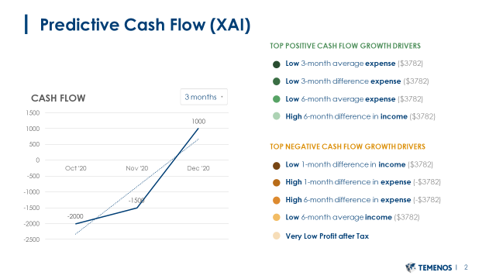

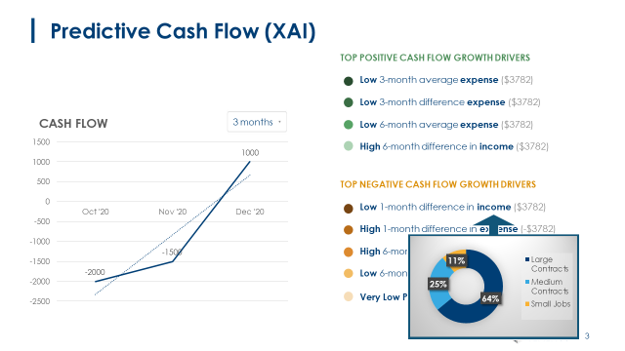
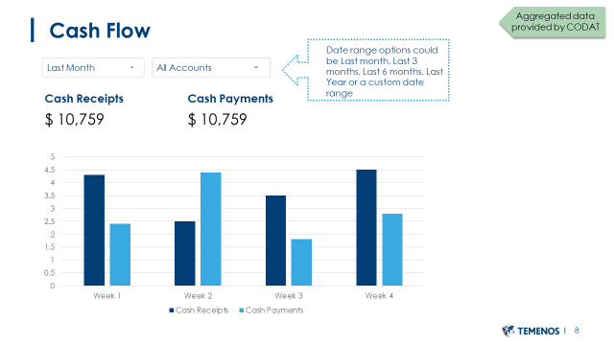

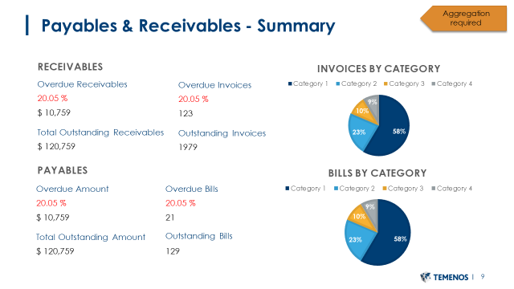
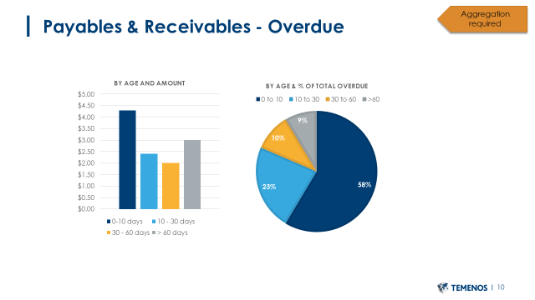

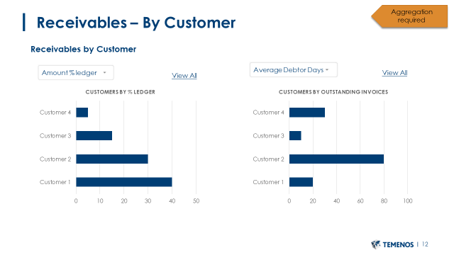
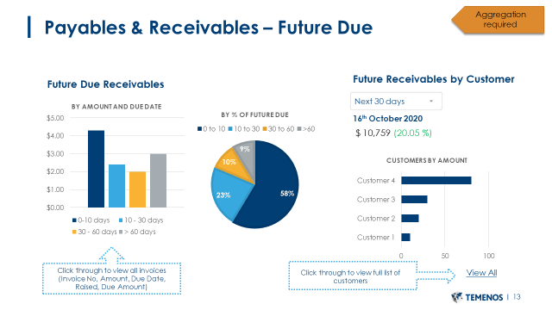

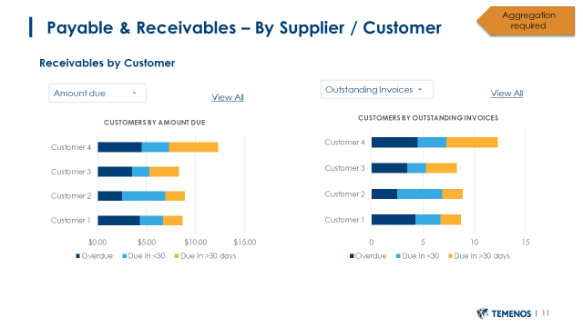

Appendix B – Cash Flow Predictive Features
